CASE STUDY ANALYSIS
Title: Full-Stack Web App Development for an E-Commerce Dashboard

Aim
To design a Full-Stack E-Commerce Analytics Dashboard using React for the frontend, Node.js with Express for the backend, and MongoDB for data storage. The system should support real-time API communication, Git collaboration, and Continuous Integration (CI).
1. Introduction
The rapid growth of online shopping has increased the need for intelligent dashboards that help businesses monitor sales, customer behavior, and product performance in real time. Traditional reporting methods are slow and do not provide instant insights for business decisions.
A Full-Stack E-Commerce Analytics Dashboard integrates a React frontend, Node.js/Express backend, and Database to display live sales information, charts, revenue reports, and inventory status. Marketing teams can analyze customer trends, while management can monitor overall business performance using an interactive dashboard.
This solution follows modern software engineering practices including Git version control, feature branching, code reviews, and Continuous Integration (CI) to ensure high-quality software development.
Problem Statement
Many e-commerce companies struggle to analyze sales data efficiently because information is spread across different systems. Manual report generation consumes time and delays business decisions.
The proposed Full-Stack E-Commerce Analytics Dashboard provides real-time visualization of sales, customers, revenue, and inventory through an interactive web application built using React and Node.
Objectives
- Build a responsive React dashboard.
- Develop REST APIs using Node.js and Express.
- Store product and sales data in a database.
- Display real-time analytics using charts.
- Ensure secure API communication.
- Implement Git-based collaborative development.
- Automate testing using CI pipeline.
- Improve dashboard performance and user experience.
Expected Outcomes
9.Fast loading dashboard
10.Real-time sales updates
11.Interactive charts
12.Secure backend APIs
13.Easy collaboration among developer

Architecture Layers
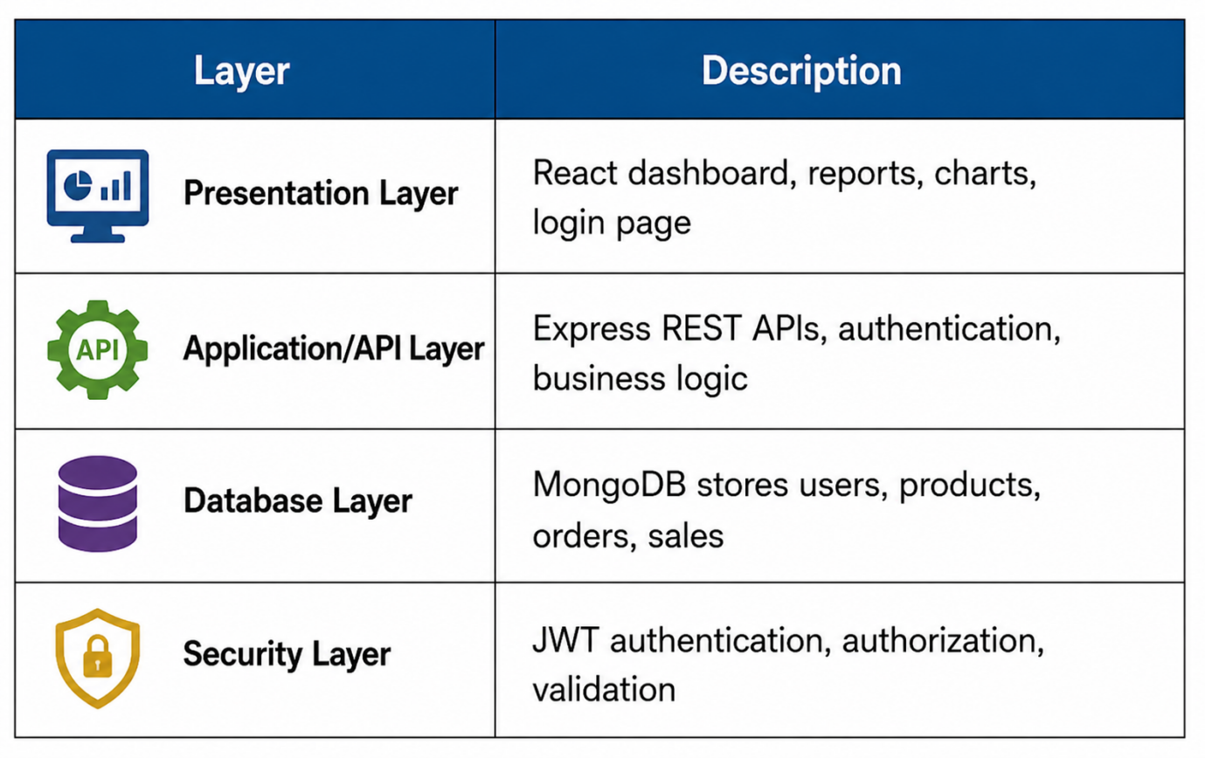

API Data Flow
Step 1
User opens the dashboard.
↓
Step 2
React sends an API request using Axios or Fetch.
↓
Step 3
Express receives the request.
↓
Step 4
Business logic is executed.
↓
Step 5
MongoDB returns data.
↓
Step 6
Express sends a JSON response.
↓
Step 7
React updates charts and reports.

Git Branching Strategy
main
├── develop
├── feature-login
├── feature-dashboard
├── feature-products
├── feature-orders
└── feature-reports

Workflow
- Create feature branch.
- Develop the feature.
- Commit changes.
- Push to GitHub.
- Create Pull Request.
- Code Review.
- Merge into develop.
- Merge into main after testing.
Continuous Integration (CI) Flow
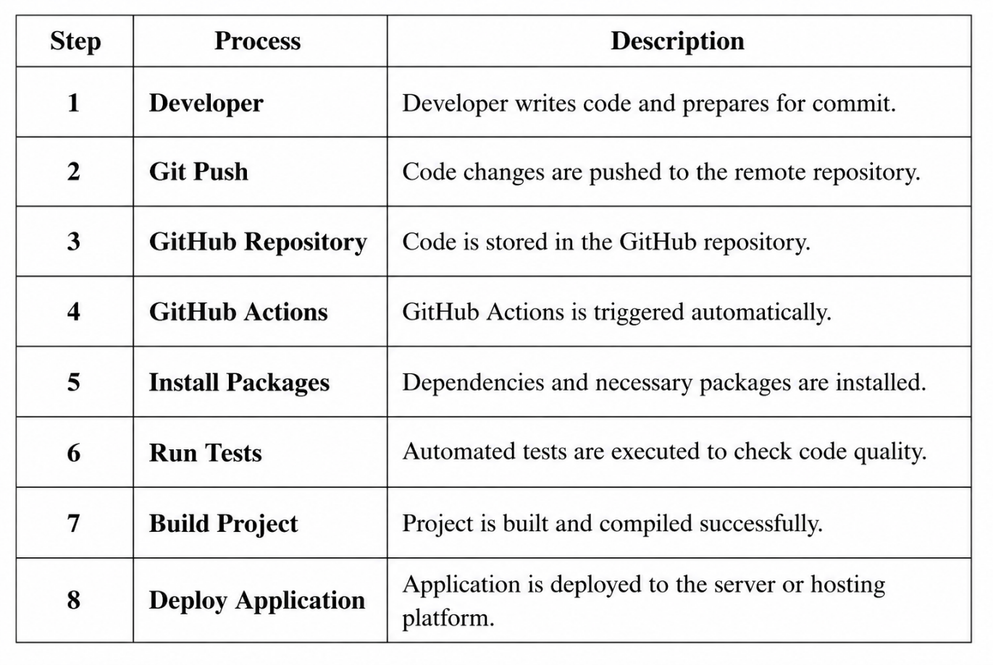
Advantages
- Fast and responsive user interface.
- Real-time analytics.
- Secure REST APIs.
- Easy team collaboration using Git.
- Automated testing and deployment.
- Scalable and maintainable architecture.
Conclusion
The proposed Full-Stack E-Commerce Analytics Dashboard combines React, Node.js, Express, and MongoDB to build a scalable and efficient web application. Git feature branching enables collaborative development, while Continuous Integration ensures reliable testing and deployment. This architecture provides real-time business insights through a fast, secure, and user-friendly dashboard.

